1. One screenshot of your modified code in VS Code and one screenshot of your browser window displaying the line: “My first GET *request*”.

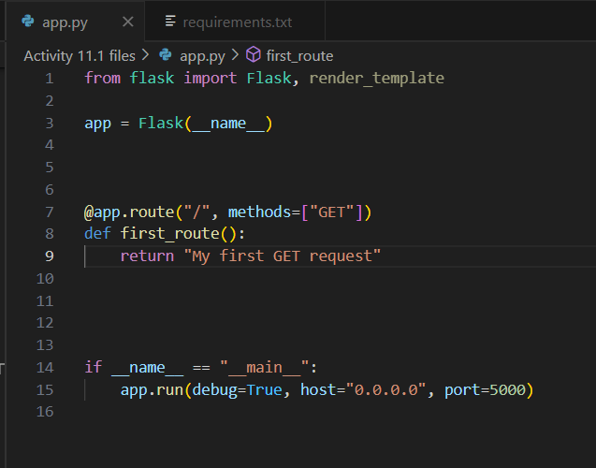

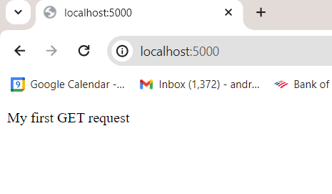

2. One screenshot of your modified code in VS Code and one screenshot of your browser window displaying the line “My first GET *request*” in HTML.

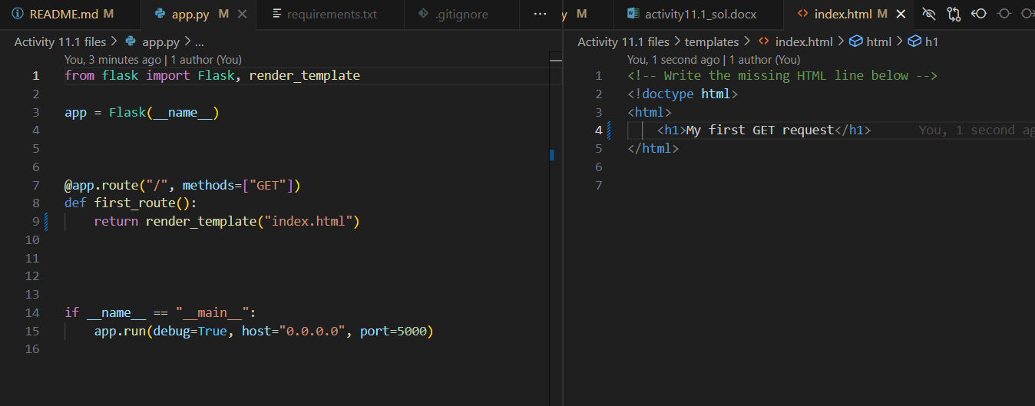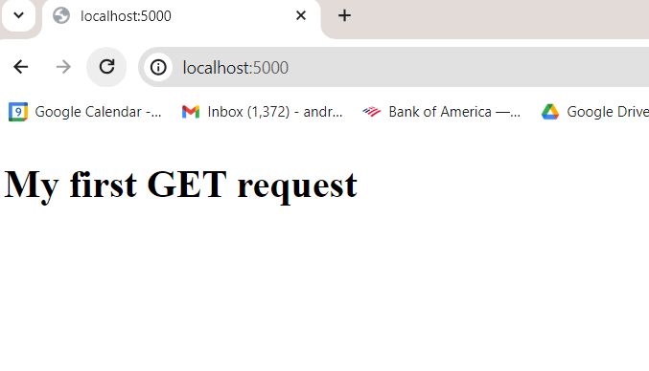

3. One screenshot of your browser window displaying the line: “Hello, my name is <your_full_name>”.

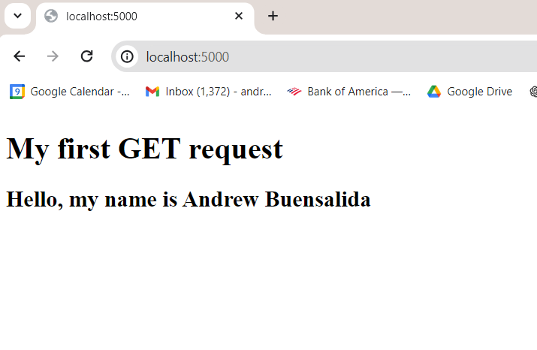

4. One screenshot demonstrating successful editing of the app.py file by modifying the *decorator* app_route().

